- How to add a custom font to my website?

Ans: Using Google Fonts –font choose—click—get font—get embeded code—copy webcode—paste in index.html header—copy css font family—paste in the css *tag

- Color Picker
https://imagecolorpicker.com/color-code/f7eaea

- How do you center align an element?

Ans: There are two ways we can use to center align an element:

- Using display: flex and justify-content: center (this will center align all the elements inside a div)
- Using margin: 0 auto; (this will take automatic place from the x-axis of an element)
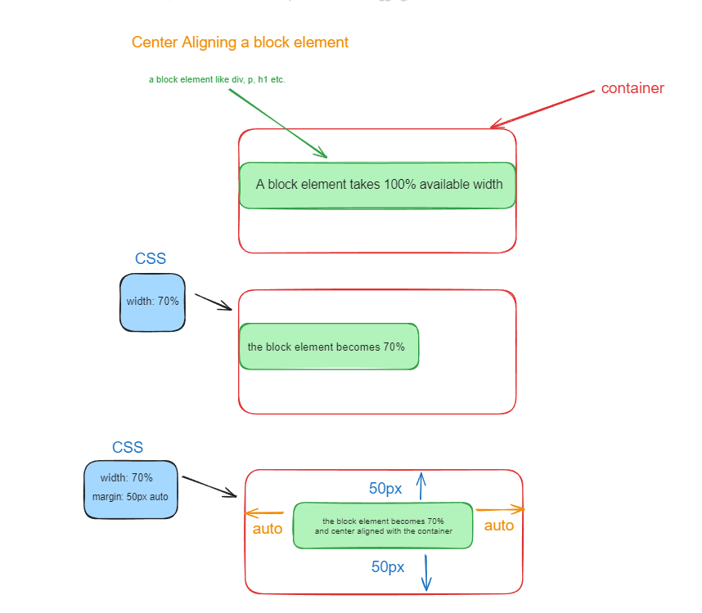
3. How can you use an icon on your website?

Ans: using font awesome.

To use Font Awesome, go to their website. Create an account, and you will receive a free tier kit. We need that kit to add a script to our HTML document's head. Then, search from thousands of free tier icons and add those icons to your webpage using <i> tag.

Note: If icons are absent, add fa to the class string.

4. CSS Grid property

CSS Grid Property allows us to mention the layout of the elements to be organized in two dimensions (rows and columns). Along with grid-template-columns and grid-template-rows properties, we can make card containers using the CSS Grid

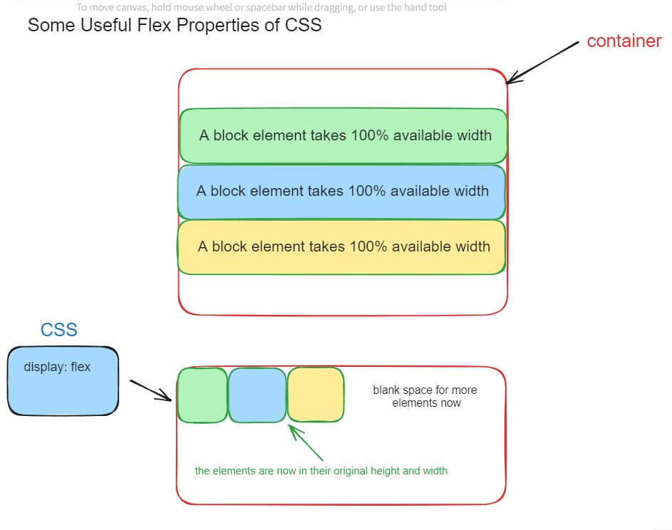
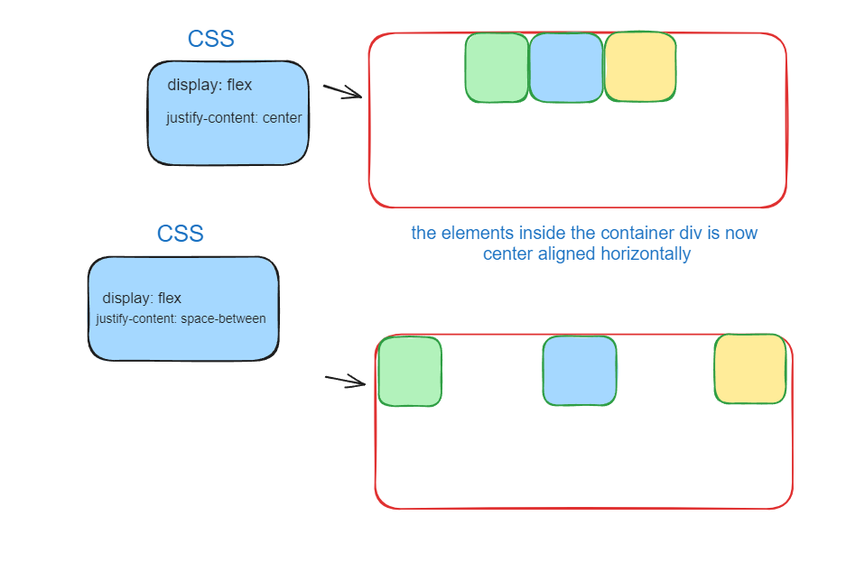
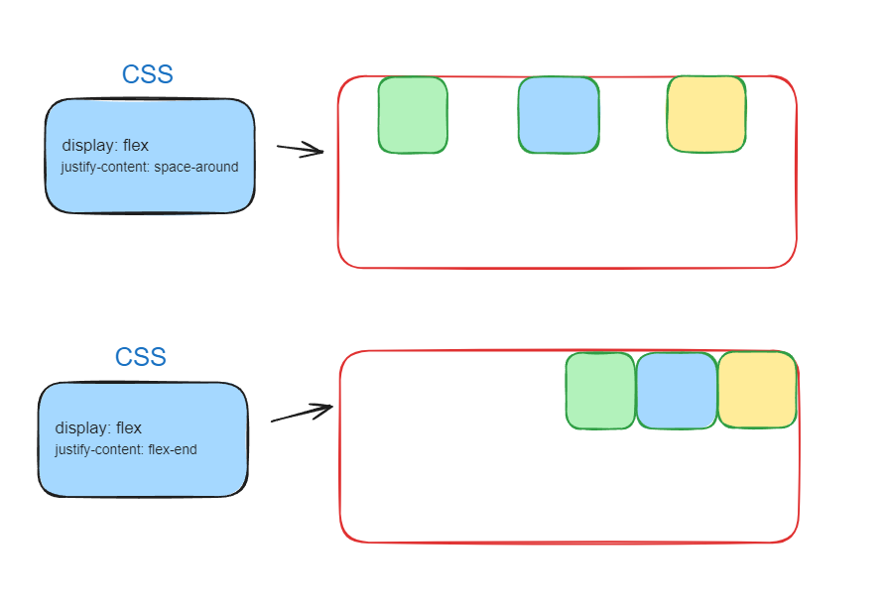
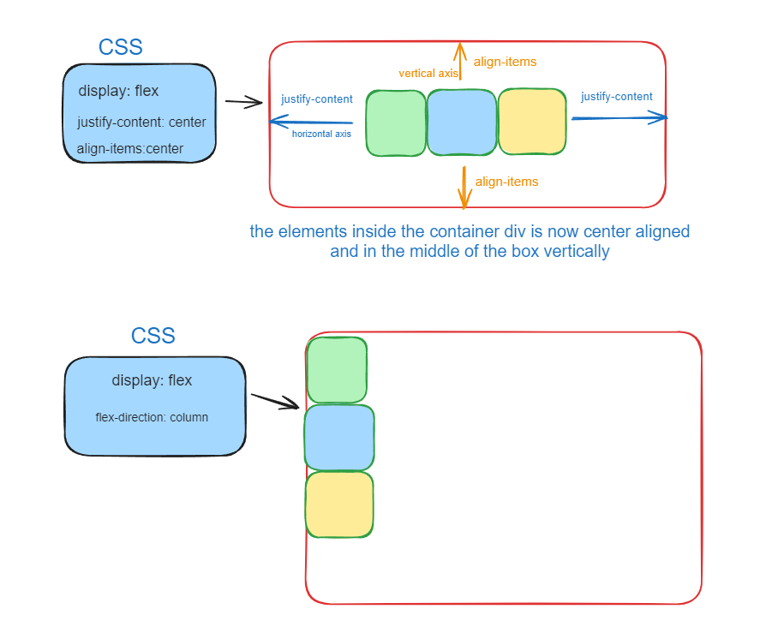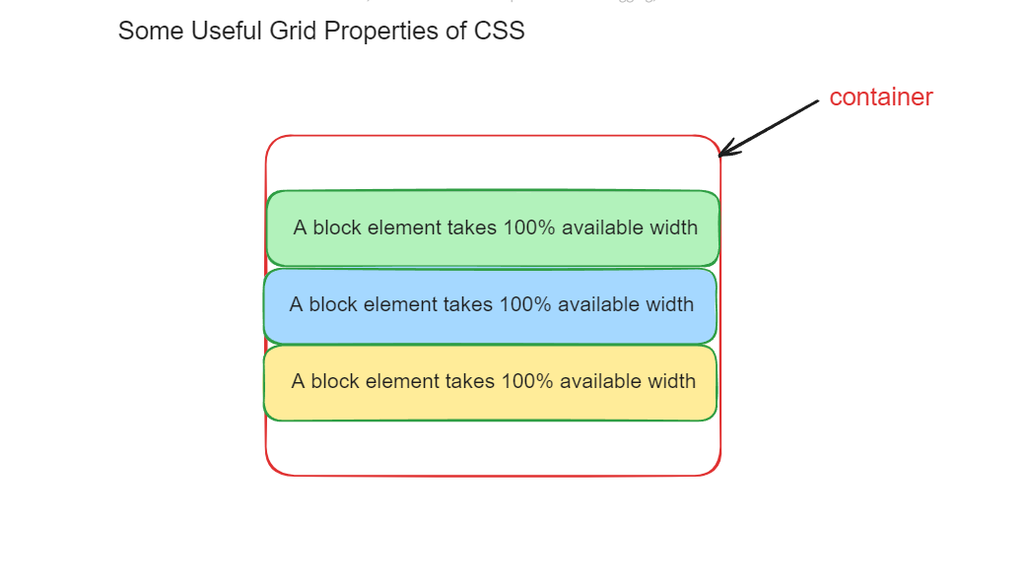
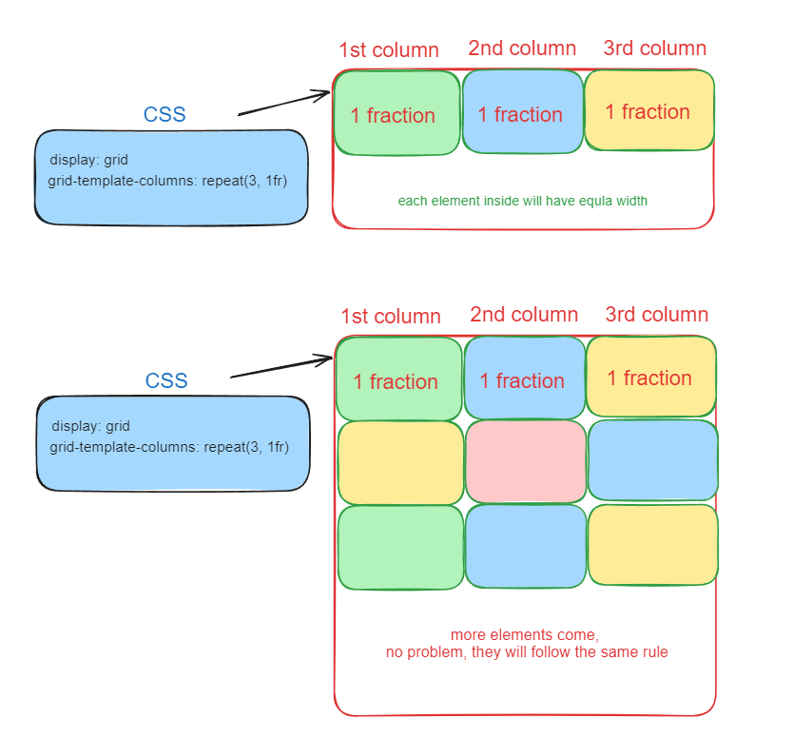
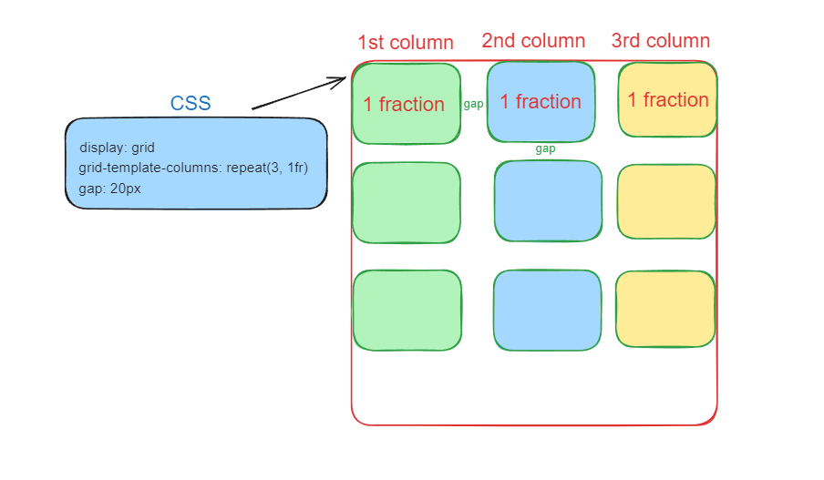

Asynchronous Programming in JS: when we try to request data from a web server, the response from the server comes to us over the Internet. We definitely need some time for the response to arrive. So, we declare the Fetch API call as asynchronous work (meaning this line of code will be executed later, and we need some time to resolve it). To declare any asynchronous work, we write await before the function. And any function that includes a single asynchronous work should have the async keyword mentioned.

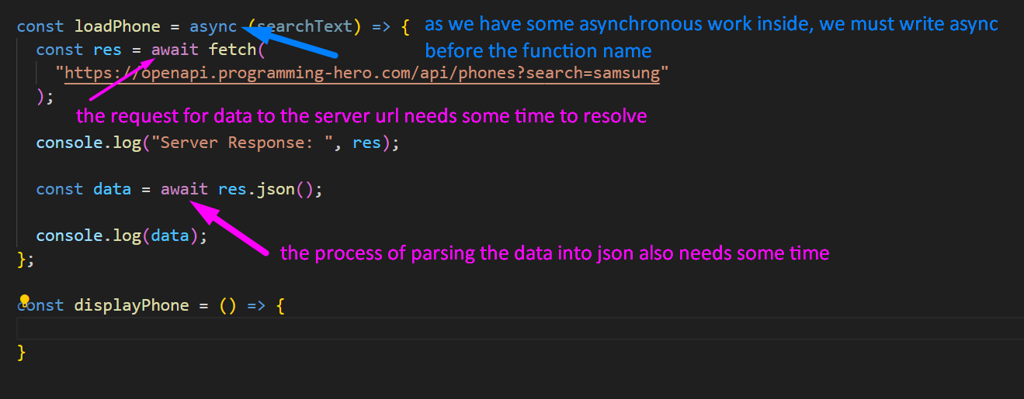
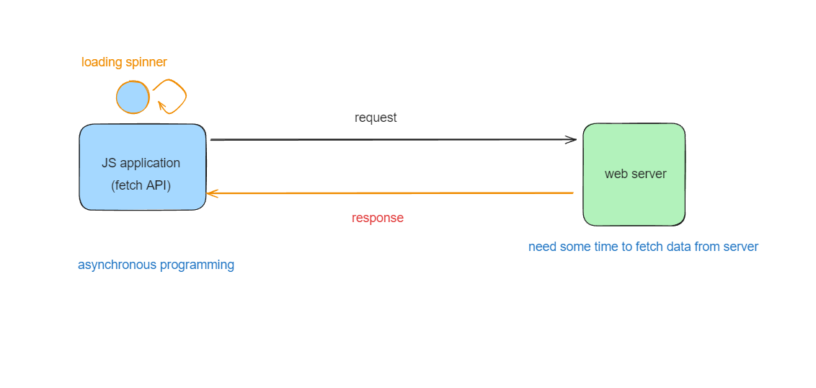

Arrow Function writing in JS:
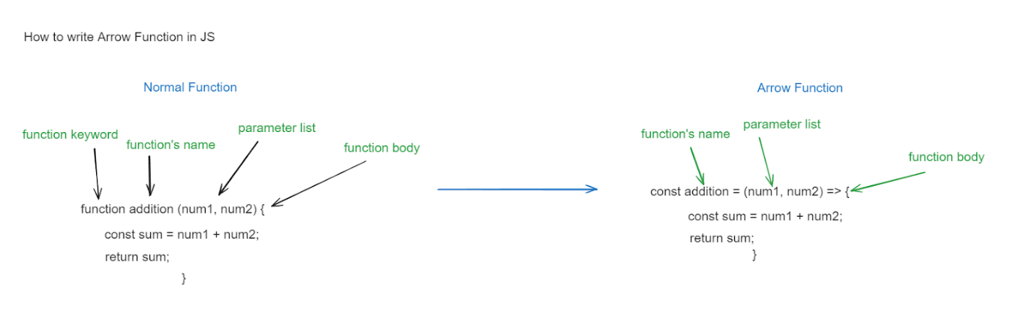

Dom Manipulation in JS:
